(Approx. 599 words)

Fix That Fan
By Jim Sanders, Editor, The Orange Bytes, North Orange County Computer Club, California
www.noccc.org
jsanders-that-ligasmicro.com

Obtained from APCUG with the author's permission for publication by APCUG member groups.

Cheap (Sleeve Bearing) fans die young. Bet on it. The cheaper the system, power supply, cooler, etc., the cheaper the fan. A cheap ball bearing fan may be just as bad. When you hear that sleeve bearing fan (or a ball bearing fan for that matter) rattle, notice a fan is barely turning, or not turning at all, fix it!

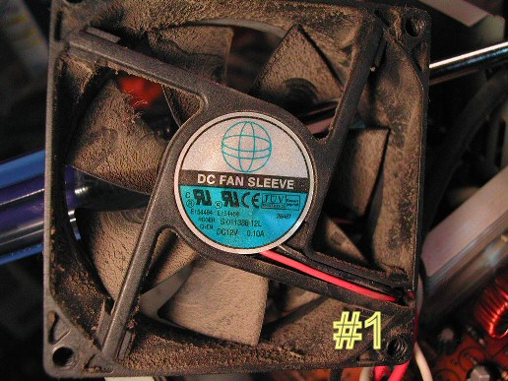
As shown in photo #1 of a fan out of a power supply, get the fan out where you can work on it. On the side where the wires go into the middle, carefully peel back the label/sticker that covers the shaft area.

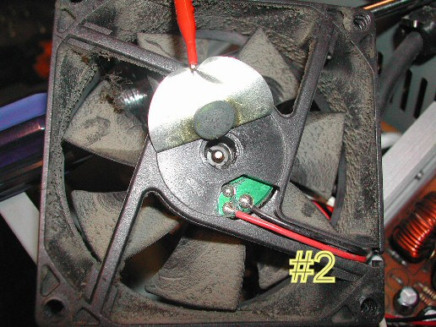
The round item in the middle of the sticker in photo #2 is a metal hole plug. The better fans have a rubber plug that seals well and is almost invisible at times. The really cheap fans don’t have a plug over the shaft area. If the fan still turns without much effort, just oiling it may make it well again. Apply a few drops of a good light machine oil such as, 3in1, Singer sewing machine, even ATF, but not the 30wt for your car engine, in the shaft hole. Sewing machine oil works well. Be careful not to get any oil on the surface where the label/sticker needs to be re-applied. This has to be put back in place to cover the opening and keep the oil in place.

If you get oil on the fan surface, it can be removed with acetone or MEK. If the label gets wrecked, I have found that on a clean surface a piece of black electrical tape works well. If you don’t have a good applicator,
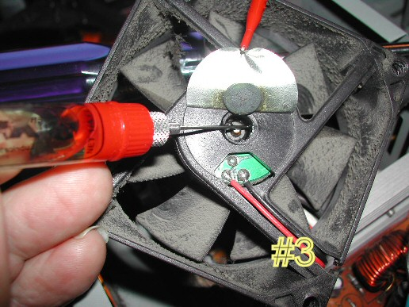
see photo #3, use a toothpick.

Spin the fan some to work the oil onto the shaft. Re-assemble and you are likely to have a fan that quietly moves air again. If the fan is so gummed up that it is hard to move the blades, you will need to remove the retaining ring (C-ring) on the shaft. This allows the

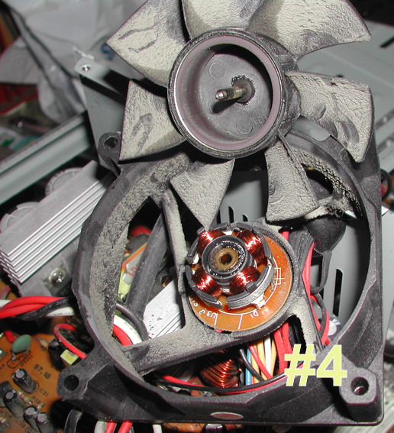
shaft to be pulled out of the bearing, see photo #4, so that both can be cleaned with a good strong solvent before oiling. I like the effectiveness of Methyl Ethyl Ketone or MEK. A pipe cleaner works well for cleaning the inside of the bearing, especially on the smaller fans.

Arguably, this is more work than it is worth, but it is not always easy to find a replacement fan.

The video card fans and the motherboard chipset fans can be near impossible to locate. Even if you find a replacement fan, oiling the fan before putting it into service maybe a good idea as manufacturers seem to be chintzy about the amount of oil in new fans.
PS - Clean the crud off the fan before you replace it. In fact, if you have access to an air compressor regulated at about 90 PSI, it is a great idea to take a blow gun attachment on the end of an air hose and blow out the entire system keeping the tip about six inches away from parts. The little duster cans are better than nothing, but really don’t have the horse power to do a good job.

This article has been provided to APCUG by the author solely for publication by APCUG member groups. All other uses require the permission of the author (see e-mail address above).

